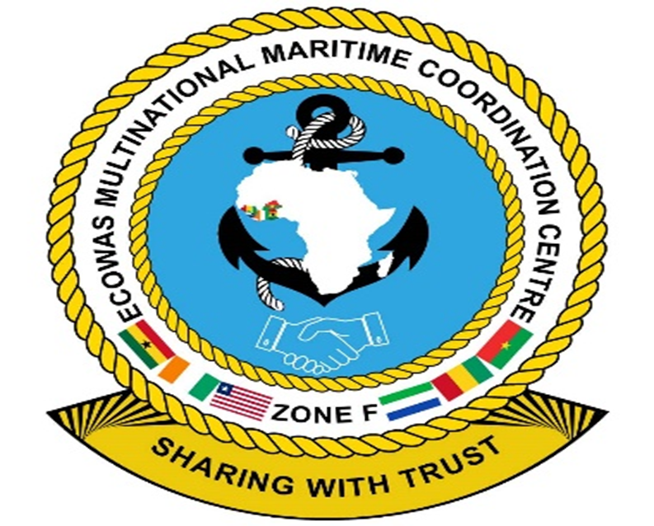

ECOWAS MULTINATIONAL MARITIME COORDINATION CENTRE (MMCC) ZONE F

MONTHLY ACTIVITIES REPORT
MARCH 2023

MARITIME SECURITY AND SAFETY REPORT FOR MARCH 2023

OVERVIEW

1. Maritime Zone F remains safe and secured, however, there was a theft incident at the Takoradi Sea Port of entry in Ghana. On 2nd March, a Danish flagged chemical tanker (Nord Stingray) anchored at the Takoradi anchorage, was boarded by an unknown man. The perpetrator fled the vessel upon hearing the alarm. Investigations were conducted and the outcomes revealed that the perpetrator escaped with 2 mooring ropes and a cover of anchor hawse pipe.

ACTIVITIES

2. The MMCC Zone F and its member states undertook various activities during the month under review. The activities conducted during the period are outlined below:

a. MMCC Zone F. The MMCC Zone F monitored vessel activities in its AoR and shared maritime information with stakeholders.

(1) Monitoring of Vessels. The Centre monitored, tracked vessels, and observed suspicious activities within Zone F AoR.

(2) Sharing of Maritime Information. The MMCC Zone F shared maritime information among maritime law enforcement agencies and other relevant stakeholders as well as coordinated response activities at sea.

(3) Hosting of Delegations. The Centre on a regular routine, do host high profile guests and other stakeholders who have interest in knowing how the centre works to safeguard and secure its AoR.

b. Ghana Maritime Law Enforcement Authorities. Ghana’s Maritime Law Enforcement Authorities conducted the following activities:

(1) Monitoring. Ghana Navy and other maritime agencies used the MDA tools available to monitor and track vessel activities in the Ghanaian waters.

(2) Patrols. Patrols were conducted to dominate Ghana’s AoR and enforce maritime, fisheries regulations and the protection of critical national infrastructures.

c. Cote d’Ivoire Maritime Law Enforcement Authorities. The Cote d’Ivoire Navy conducted patrols to dominate its AoR and enforced maritime regulations.

d. Liberia Maritime Law Enforcement Authorities. The Liberian Coast Guard undertook the following activities:
(1) Patrols. Conducted rigorous patrols to dominate its AoR and enforce maritime regulations.

(2) Fisheries Law Enforcement Patrols. The Liberian Coast Guard conducted fisheries law enforcement patrols and search over the period.

e. Sierra Leone Maritime Law Enforcement Authorities. The Sierra Leone Navy conducted the following activities:

(1) Fisheries Monitoring and Surveillance. The Sierra Leone Joint Operations Centre monitored and coordinated activities within their AoR, including monitoring fishing activities.

(2) Patrols. Patrols were conducted to dominate the AoR and enforce maritime regulations, including IUU fishing.

f. Guinea Maritime Law Enforcement Authorities. The Guinean Navy conducted the following:

(1) Monitoring. Maritime prefecture, Guinea Navy and other maritime agencies used the MDA tools available to monitor and track vessel activities in the Guinean waters.

(2) Patrols. Patrols were conducted to dominate Guinea’s AoR and enforce maritime regulations.

(3) Enforced Regulations on Illegal Ship to Ship Activities. Guinean Maritime Law Enforcement Authorities conducted patrols to dominate its AoR and enforce maritime regulations.
MARITIME INCIDENTS RECORDED

Category | Type of Incidents | No Incident in the Recorded
 |  | Ghana | Cote d’Ivoire | Liberia | Guinea | Sierra Leone
Terrorism | Terrorism | Nil | Nil | Nil | Nil | Nil
Piracy/Armed Robbery | Hijacking | Nil | Nil | Nil | Nil | Nil
 | Kidnapping | Nil | Nil | Nil | Nil | Nil
 | Armed Robbery | Nil | Nil | Nil | Nil | Nil
 | Fired Upon | Nil | Nil | Nil | Nil | Nil
 | Boarding | Nil | Nil | Nil | Nil | Nil
 | Theft | 1 | Nil | Nil | Nil | Nil
Illicit Trafficking | Human | Nil | Nil | Nil | Nil | Nil
 | Drug | Nil | Nil | Nil | Nil | Nil
 | Weapons/Ammunitions | Nil | Nil | Nil | Nil | Nil
 | Smuggling | Nil | Nil | Nil | Nil | Nil
IUU Fishing | Industrial Fishing | Nil | Nil | Nil | Nil | Nil
 | Craft Fishing | Nil | Nil | Nil | Nil | Nil
Pollution |  | Nil | Nil | Nil | Nil | Nil
Illicit Migration | Organised Migration | Nil | Nil | Nil | Nil | Nil
 | Stowaways | Nil | Nil | Nil | Nil | Nil
Illegal Transfer | Illegal Bunkering | Nil | Nil | Nil | Nil | Nil
 | Oil Robbery | Nil | Nil | Nil | Nil | Nil
Cyber Criminality |  | Nil | Nil | Nil | Nil | Nil
Maritime Accident | Shipwreck | Nil | Nil | Nil | Nil | Nil
 | Collision | Nil | Nil | Nil | Nil | Nil
 | Sinking | Nil | Nil | Nil | Nil | Nil
 | Damage | Nil | Nil | Nil | Nil | Nil
Search and Rescue | Men Overboard | Nil | Nil | Nil | Nil | Nil
 | Assistance and Towing | Nil | Nil | Nil | Nil | Nil
 | Sanitary Evacuation | Nil | Nil | Nil | Nil | Nil
 | Capsizing | Nil | Nil | Nil | Nil | Nil
 | Rescue at sea | Nil | Nil | Nil | Nil | Ninm1
Others | Loss of Contact | Nil | Nil | Nil | Nil | Nil

PIRACY THREAT ASSESSMENT FOR THE MONTH OF APRIL 2023

4. The piracy risk assessment for APRIL 2023 is as follows:

a. The threat of pirate attacks is likely in Maritime Zone F.

b. Attack on fishing vessels operating in Maritime Zone F remains likely following the history of these events.

c. Maritime Zone F is expected to be relatively safe. However, the possibility of unauthorised boarding and theft within ports/anchorages, especially the Takoradi and Conakry anchorage areas, remains likely.

ILLEGAL FISHING THREAT ASSESSMENT FOR THE MONTH OF APRIL 2023

5. Illegal fishing assessment for April 2023 is as follows:

a. Illegal fishing will persist due to the coastal states weak legal regimes for enforcement to deal with the situations and their inability to adequately implement measures.

b. The conduct of activities at the blind side of maritime law enforcement agencies by both local and foreign vessels is likely to continue.

ILLEGAL TRANSFERS THREAT ASSESSMENT FOR THE MONTH OF APRIL 2023

6. Illegal transfers’ assessment for April 2023 is as follows:

a. The likelihood of illegal transfers, including drugs, oil and other contraband goods, remains likely following their history of occurrence.

b. Both local and foreign vessels may engage in these activities without being spotted by maritime law enforcement agencies.

RECOMMENDATIONS

7. The following are recommended:

a. All vessels transiting within the Maritime Zone F, the sea area from Guinea to Ghana, are advised to remain vigilant, maintain a sharp lookout, apply the BMP West Africa, and report any suspicious activities to the relevant authorities.

b. Vessels within ports and at anchorages, especially Takoradi and Conakry ports/anchorages, are advised to remain vigilant and rotate crew on watch regularly, especially at night, to prevent petty theft and robberies.

c. Vessels are advised to desist from loitering around or drifting unnecessarily offshore to prevent them from being vulnerable to pirate’s attacks.

d. Coastal law enforcement agencies are encouraged to monitor maritime activities such as IUU, marine pollution, drug, weapon and human trafficking, stowaways, and illegal ship-to-ship transfers.

9. The MMCC Zone F maintains a 24-hour operations centre. Shipowners and maritime stakeholders can contact the Centre via hotlines at +233 547976523/+233 302736804 or via email at zonefmmcc@gmail.com/zonefmoc@gmail.com to access or report any incidents. The information received from vessels, shipping agents, Company Security Officers (CSOs) and other partners is treated with the utmost confidentiality and shared promptly on a need-to-know basis to coordinate responses.

4 April 2023

